Blogger Archiving Utility
Welcome to the blogger archiving utility. This program is designed to allow you to download your blogger blog as well as to archive the blog to a PDF document for printing.

The application is hopefully very simple to use – the hardest part is getting your blog id! This is the unique id that is assigned by blogger and allows the application to access your posts, images, etc...

To find this mysterious blog id, log in to your blog and look at the url in the browser's address bar – it should read something like the following:
http:/blogger.com/post-create.g?blogID=XXXXXXXXXX

Make note the long string of numbers after blogID= - that is your blog id and will be used to set-up communication between this app and your blog.

There are two features of the app – the first is the ability to download your blog. You access this feature using the Download Blog feature on the initial screen of the app.
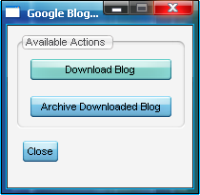

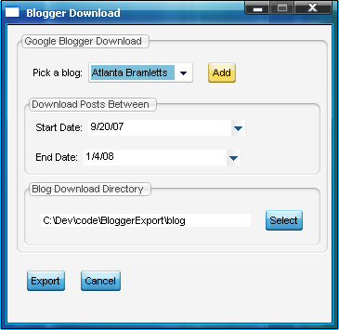
Clicking this button takes you to the main blog download page.

Next you will need to add your first blog, press the Add button to bring up the Add a blog function.

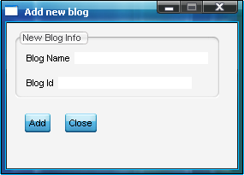

Here enter a name for this blog definition – this blog name is just something for you to remember the blog. Next enter the blog id, remember this is the number found in the url of your blog when you log in to administer it (it is not the url of your blog) and press Add to add this blog.

After your blog is added you will be back at the main download screen, select the date range for the blog postings you are interested in and select the directory to download to. This information will be stored by the system thus allowing you to download subsequent posts in the future (see note at the end of this document for how this is handled). Once the information is to your satisfaction press Export to download your blog.

The second feature of the app is the ability to take a downloaded blog and create a PDF document from it. On the main screen select the Archive Downloaded Blog button to bring you to the archiving function of the app.

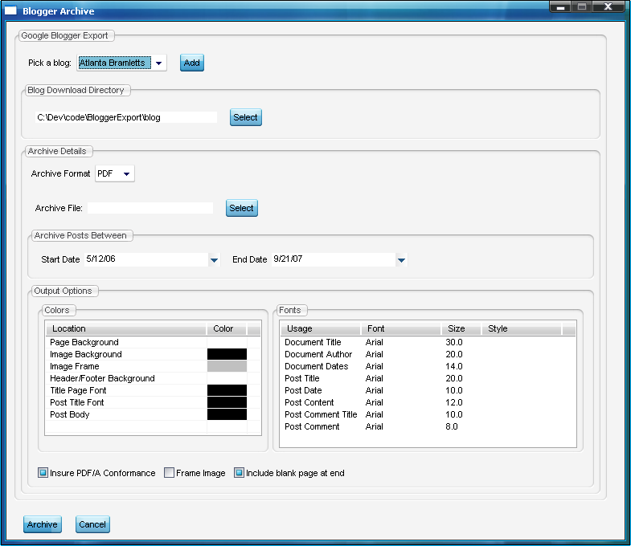
First, select the blog you want to work with – there really shouldn't be a need to add a blog here as the blog should already be downloaded but the option exists if for some strange reason you need it. By picking a blog from the list (i.e.one you've already downloaded) then you should get some defaults filled out for you automatically like the directory the blog data is in along with the start and end date posts. Next select the archive format you want. You can also select a different date range if you only want to archive a subset of posts.

If you are archiving to PDF you have the ability to custom the coloring and fonts of the creating document. Clicking an entry will bring up a window allowing you to customize the selected setting.
Once you have all the information entered press Archive to generate your archive.

Note:
A couple of notes on the download process. The app is set-up to allow you to download the blog over time, by default after the initial download when you come in to the download blog portion of the app the date range for your blog will default to the end date from your last download through the current date. That being said, when assembling the blog for export to PDF the app is smart enough to merge all of these downloads together in to a single collection, if in this merge process it encounters the same post twice it picks the most current post.

